FREQUENCY TREES
Pearson Edexcel - Tuesday 6 November 2018 - Paper 1 (Non-Calculator) Foundation Tier

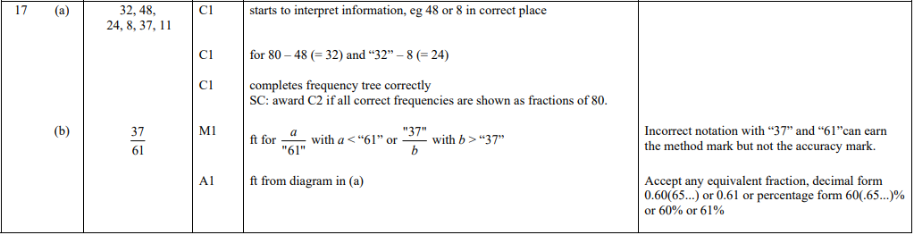

Pearson Edexcel - Thursday 7 June 2018 - Paper 2 (Calculator) Foundation Tier

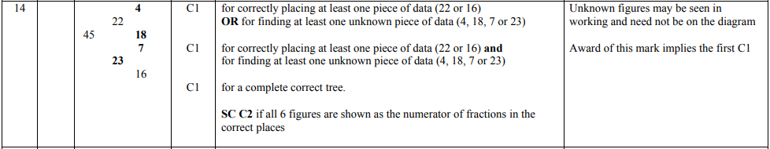

Pearson Edexcel - Monday 6 November 2017 - Paper 2 (Calculator) Foundation Tier

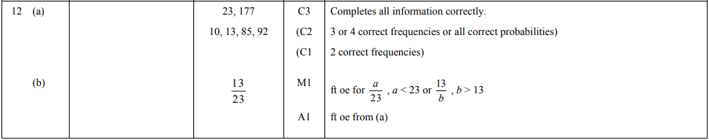

OCR Tuesday 11 June 2019 – Morning (Calculator) Foundation Tier
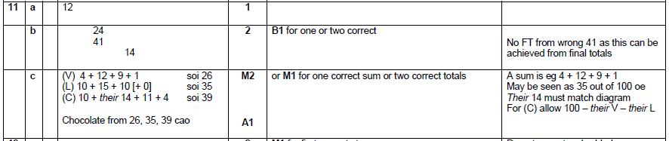

OCR Thursday 2 November 2017– Morning (Calculator) Foundation Tier
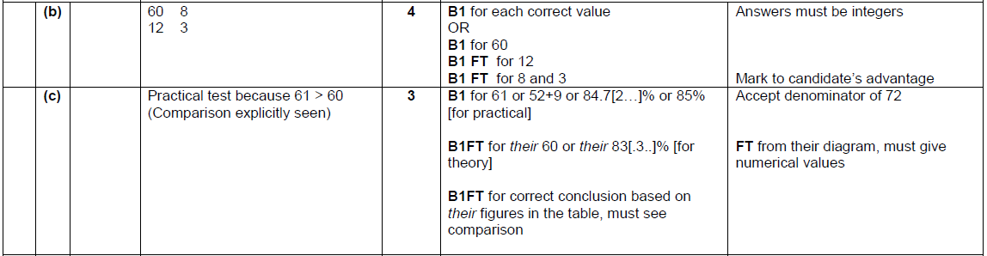

Pearson Edexcel – Sample Papers - Paper 1 (Non-Calculator) Foundation Tier

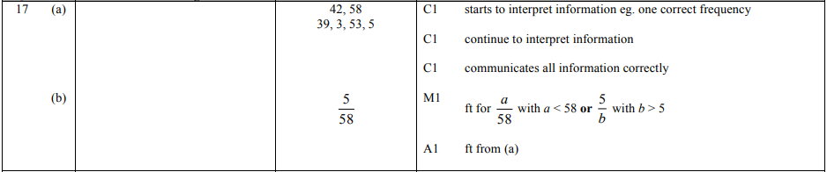
OCR Wednesday 8 November 2017– Morning (Calculator) Foundation Tier

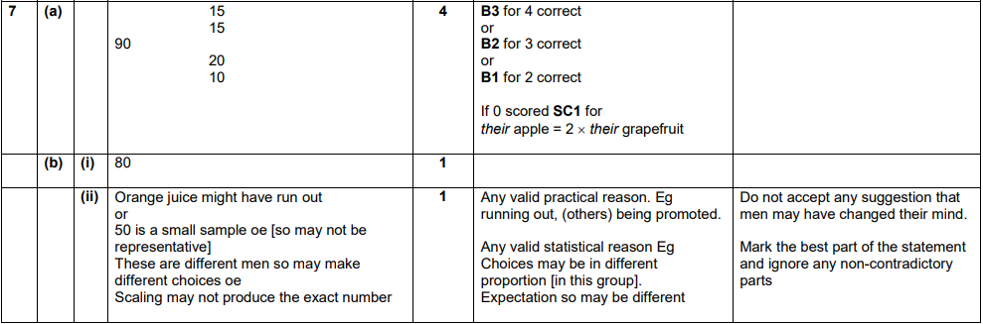

AQA Monday 8 June 2020 – Morning (Calculator) Foundation Tier

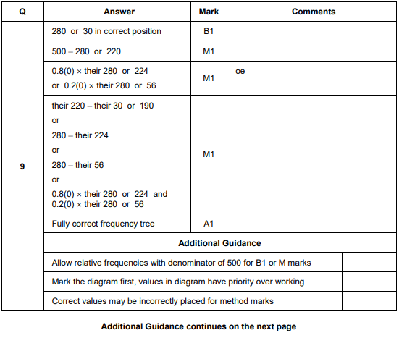
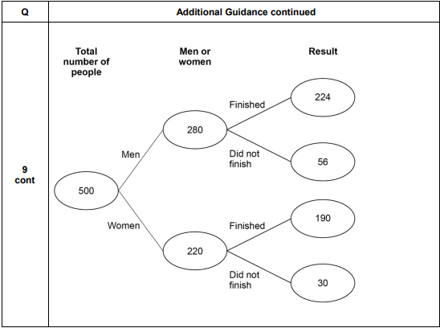
AQA Thursday 6 June 2019 – Morning (Calculator) Foundation Tier

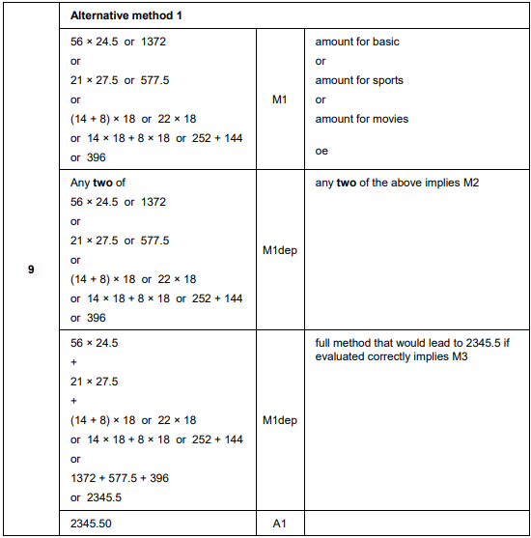
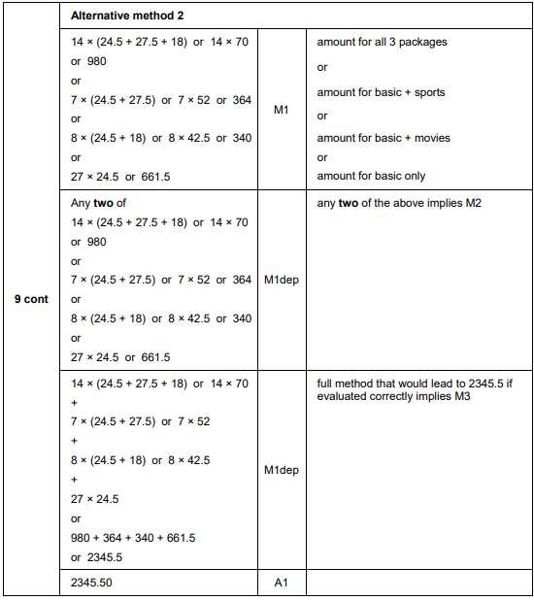
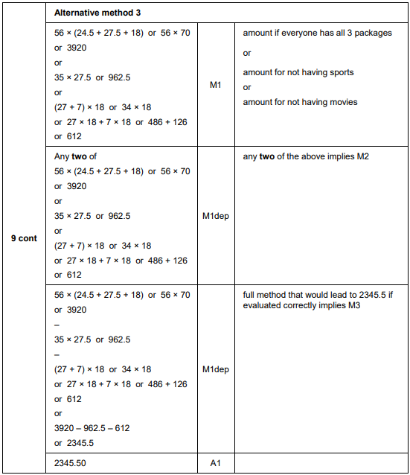
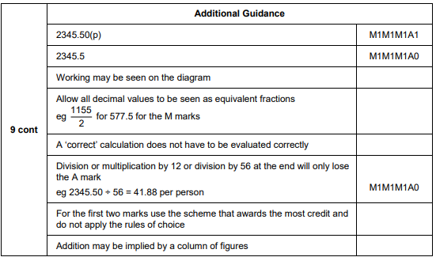
AQA Tuesday 6 November 2018 – Morning (Non-Calculator) Foundation Tier

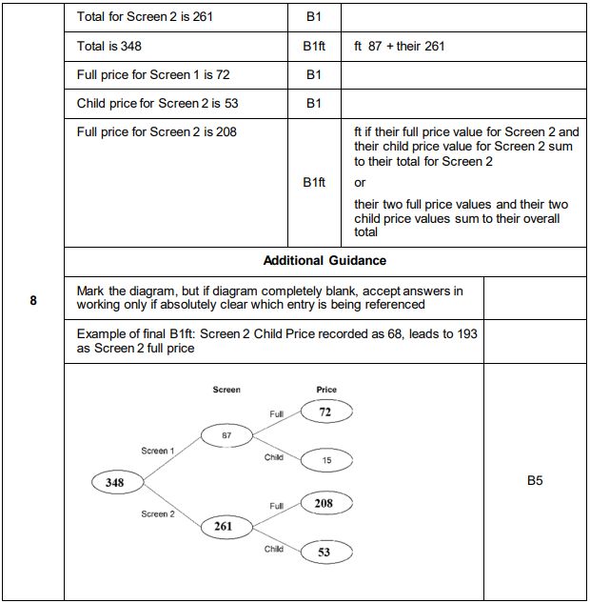

AQA Tuesday 12 June 2018 – Morning (Calculator) Foundation Tier

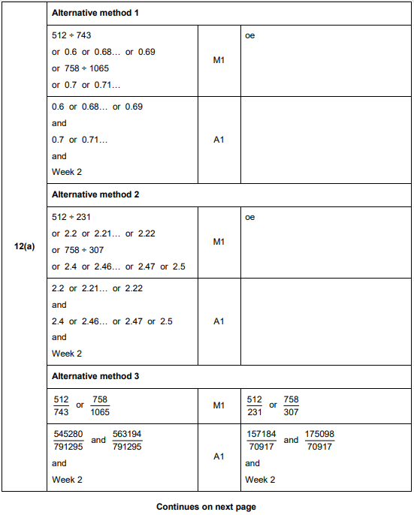

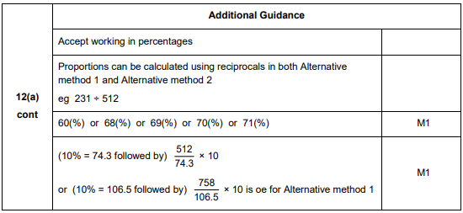
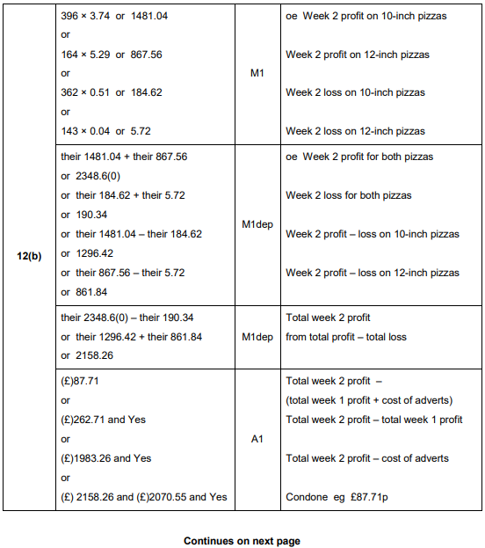
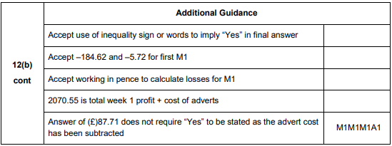
AQA Wednesday 8 November 2017 – Morning (Calculator) Foundation Tier

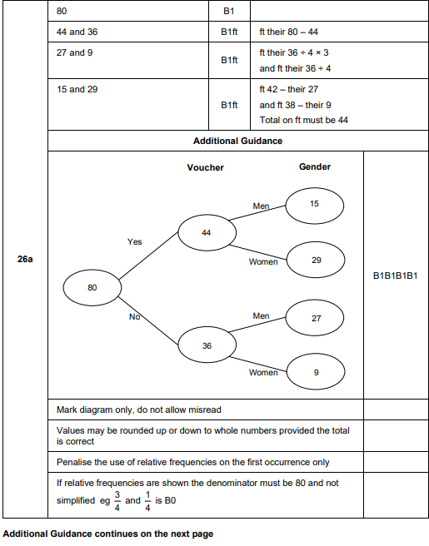
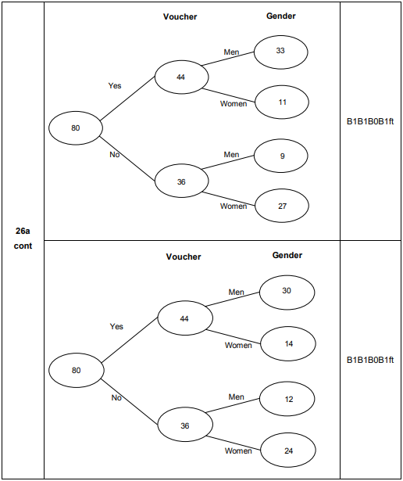
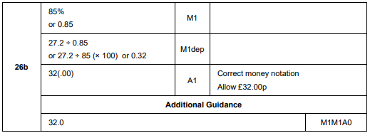

AQA Thursday 25 May 2017– Morning (Non-Calculator) Foundation Tier

